Hello DOZ TV Hosts and Co-Hosts!

If you are not familiar with using zoom first watch this video.

Note: You will need to download zoom to either your phone or computer. (I suggest both.) Go to www.zoom.us. You will need to register, but you do not need to upgrade or pay for additional services. The basic Zoom is FREE.

Zoom basic requirements: (www.zoom.us)
System requirements
- An internet connection – broadband wired or wireless (3G or 4G/LTE)
- Speakers and a microphone – built-in, USB plug-in, or wireless Bluetooth.
- A webcam or HD webcam - built-in, USB plug-in, or: An HD cam or HD camcorder with a video-capture card. Note: See the list of supported devices.

Equipment to use for Top Quality for Zoom Recordings.
- Video Capture
  - Your phone with camera capabilities; or
  - Computer with HD video webcam installed.
- Mounts.
  - Purchase a tripod and camera mount with light.
  - For Computer. Place on desk or hard surface.
- Audio.
  - Phone. Purchase earphones or earpods to block out the surrounding noises. (Note: When purchasing earphones for your phone, make sure it’s the correct ones before you buy.)
  - Computer. Purchase headset or use earphones.
- Speed/Bandwidth.
  - Phone. Use it without wifi.
  - Computer. Make sure you’ve getting 5 bars and if not, move closer to your router. In some cases, you may have to invest in a higher speed for your home.
- Location. Be comfortable. You can be sitting in your easy chair, at your table, anywhere EXCEPT your bathroom, bedroom and outside! Some people purchase a back drop but it’s not necessary. Just see above and make sure the area isn’t too clutter – unless it’s a book shelf.
- Lighting.
  - Face the window (see above), but if you really need better lighting then think about investing in these:
    - Phone lighting - See above for link to 3-in-one (tripod, mount and light.)
    - Computer lighting – mounted on the computer. (Link)
- Dress. Only your top will show. So make sure you have a nice solid top on or one that is not too busy and have your hair and makeup done.

Six Ways To Instantly Improve Video Quality On Zoom
Created by Chip at ChipCreative in 2020

Step 1. Enable HD

First, head to settings on the Zoom app.

If you aren’t currently on a call, the settings ‘cog’ is in the top right corner of the app.
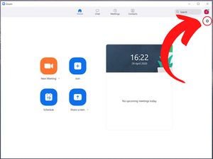

If you’re already in a call, hit the up arrow next to the video button in the bottom left corner.
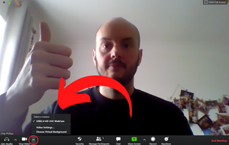

Head to the video tab on the left hand side, make sure ‘Enable HD’ is selected. Boom! Step 1, done.
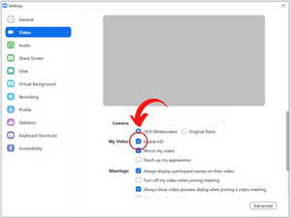

Step 2. Eyeline

No one wants to see up your nostrils, and if they do, you shouldn’t be on a Zoom call with them. Raise your laptop so the webcam is level with your eyes. You can use a laptop stand or just a pile of books. If you’re using your phone and regularly hold business meetings, I would suggest purchasing a super cheap tripod, or again, get creative with some books. Holding your phone makes you and your background generally shaky, it’s distracting for everyone - fixing your camera in position helps keep the focus on you.

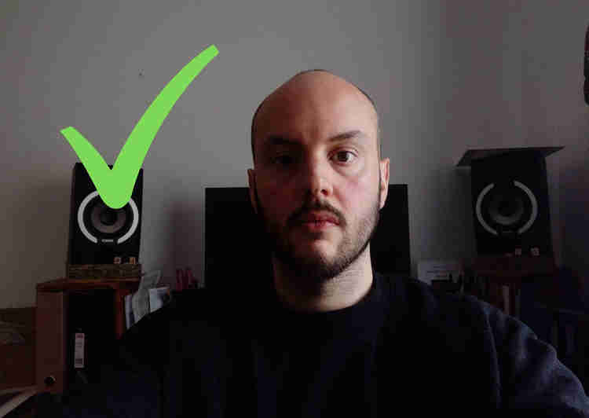

*Note* If you’re trying to make an important point in a meeting, try and maintain eye contact on your camera lens, it may feel uncomfortable to begin with, but for everyone in the meeting it will help draw them in, and give a feeling that you’re addressing them directly.

Step 3. Let There Be Light

Situate yourself by a north-facing window (south-facing if you’re in the southern hemisphere). By doing this, we situate ourselves by a nice big light source, that will never receive direct sunlight. This is important. Soft light is generally considered to be more flattering, so eliminating direct sun removes the harsh highlights and shadows that go with it. Not only that, you won’t have to worry about sunlight glaring in your eyes. Don’t panic if you don’t have access to a north-facing window, just think where the sun is relative to you at that time of day. If it’s morning time and the sun is rising in the east, then look for a west facing window instead. Vice versa for afternoon!

Once you’ve found your window, face towards it, and sit so you’re 3 or 4 feet away from it. As an optional extra, you could rotate yourself 30-45 degrees. This should add a slight shadow to one side of your face, helping create depth in your image.

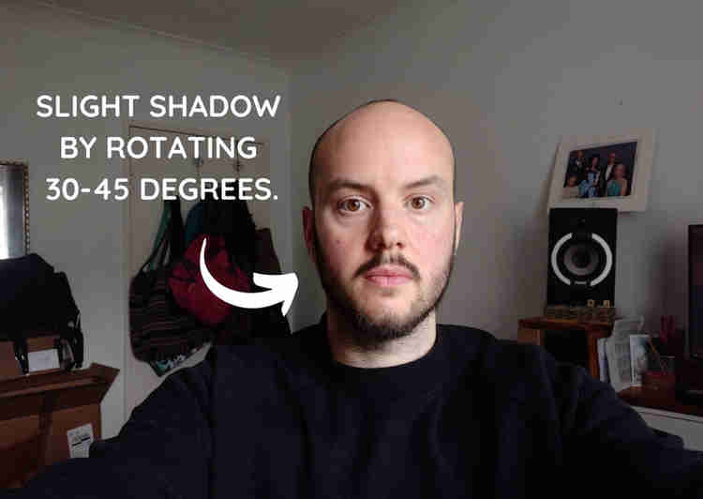

Step 4. Audio

Arguably the most important element of your call. To improve your call quality, wearing headphones is a must, and not just for you! Ask other people in your meeting to wear headphones too. It will eliminate any feedback (that annoying moment when you hear what you’ve just said playing through someone else's speakers). Sit nice and close to your laptop if you are using an onboard microphone. If you’re using your phone and your headphones have an inbuilt microphone, perfect!

Note: I know I mentioned at the beginning, no purchases necessary, but if you were to spend some money, my suggestion would be on a USB microphone such as the Movo UM700 (Amazon link). If you’re using Zoom for business calls, it really can make or break a call. We are much more forgiving with picture quality, the moment audio starts breaking up, we can lose patience very quickly.

Step 5. Declutter

Now I’m not suggesting a full deep clean of the house here (unless you are that way inclined), but do try and remove any objects that are sitting (or hanging) directly behind your head.

Webcams and phone cameras generally have a large depth of field (where things close up and far away are all in focus), this unfortunately means any items behind your head will be in focus and really distracting.

So, do your best to remove them, again this helps keep the focus on you.

Step 6. Bandwidth

With potentially many household devices connected to WiFi, temporarily disable them to free up your bandwidth for the call. You may have your laptop on for your Zoom call, while your phone, desktop PC, iPad and smart TV are all draining on your internet speeds. Turning off WiFi on other devices could really free up some bandwidth, and lead to a much smoother call. If others in the house are streaming videos, maybe ask them really, really nicely if they’ll stop for the duration of the call.

For questions, email or text Vikki Wells. 213.713.0260. vikki@thatagirlspeakers.com

